ISLAMIC UNIVERSITY OF TECHNOLOGY

Organization of Islamic Cooperation

Board Bazar, Gazipur

Laboratory Report

CSE 4512

**Title**: Understanding the concept of VLAN and configuration of VLAN to multiple user groups in different locations and configuration of Inter VLAN routing.

**Objective**:

* Create VLANs and Assign Switch Ports
* Configure an 802.1Q Trunk between the Switches
* Configure Layer 3 Switching
* Configure and Verify Inter-VLAN Routing

**Devices/Software Used**: Cisco Packet Tracer

**Theory**:

VLAN Definition: VLAN is a logical grouping of network devices. Essentially, devices that are spread out across multiple physical networks can be connected via a logical network to allow them to communicate securely and privately. The combined, larger broadcast domain consisting of all the devices on the different physical networks is broken down into a smaller broadcast domain without affecting the physical setup.

Usage of VLAN: VLAN is used in scenarios where there are several devices that are part of multiple different physical networks that need to be connected to allow them to communicate privately. For example, consider a university where devices belonging to administrators must be able to communicate privately. If we use the existing network, which connects every device in the university, then non-administrative devices will be able to listen to any broadcast messages. One solution to this is to connect the administrative devices to their own network physically, but if the devices are at different locations, this is impractical. VLAN solves this putting the administrative devices on a virtual network instead, where the other devices on the same physical network cannot intercept their broadcasts. Additionally, the smaller broadcast domain improves performance.

Inter VLAN Routing: Inter VLAN routing refers to the process of devices on different VLANs communicating with each other. The first step is to ensure that each VLAN has its devices on a different network. The physical networks do not need to be changed for this, just the logical ones. Once this is done, the physical network can be connected to a router through a single interface. This interface is divided into multiple sub-interfaces, one for each VLAN. Each sub-interface can be configured to work as the default gateway for a separate VLAN. The exact commands required to set all of this up is provided below.

**Diagram of the experiment**:

Task #01:

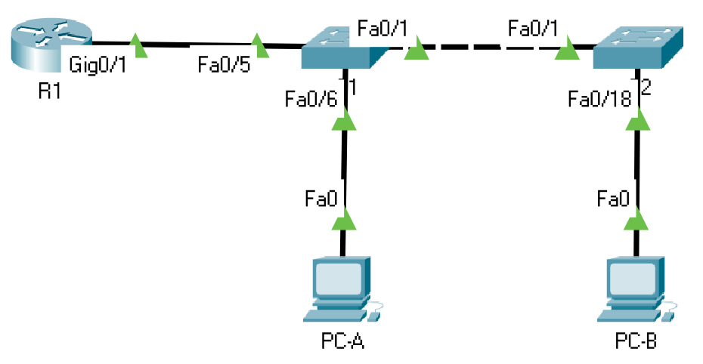

Task #02:

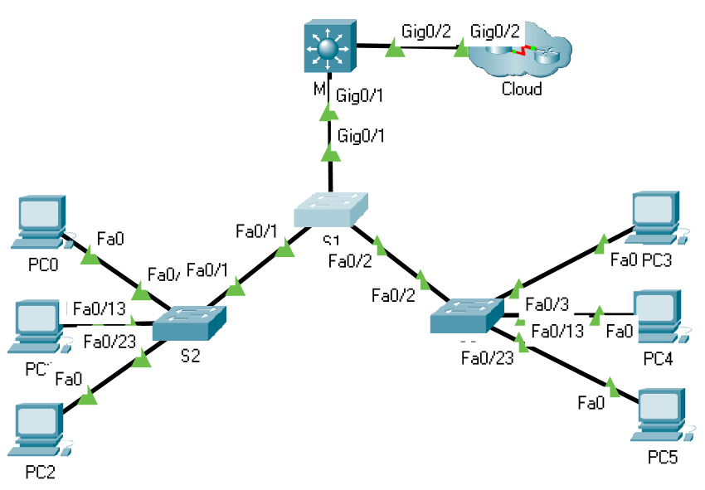

**Working Procedure**:

TASK #01:

1. The devices were set up as shown in the diagram above.
2. The basic settings for the router was configured as shown below.

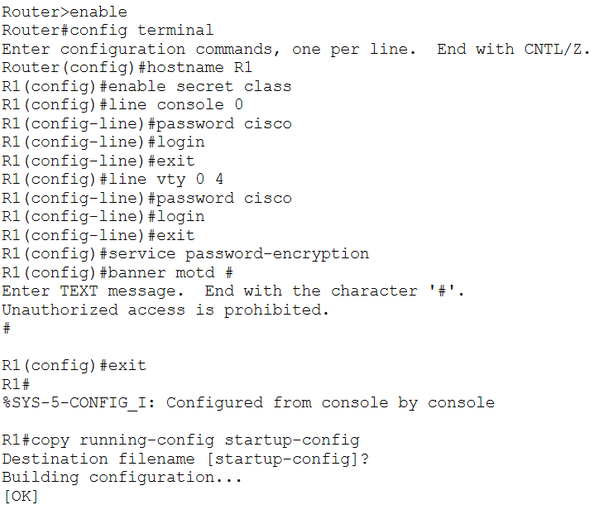

1. The basic settings for switch S1 were configured as shown below:

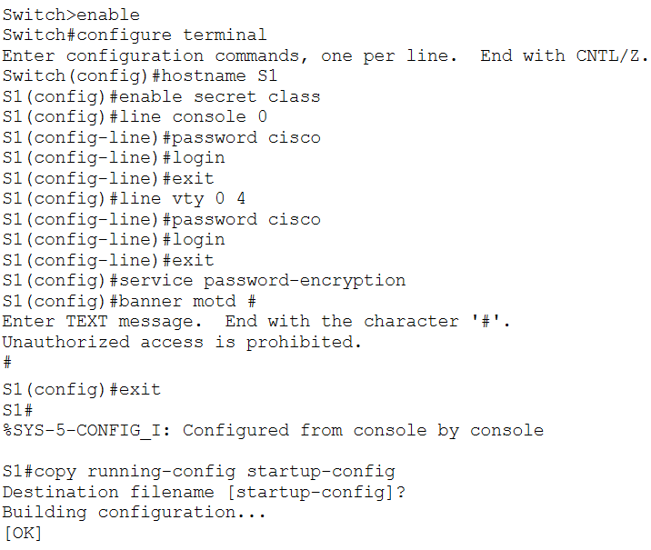

1. The basic settings for switch S2 were configured.

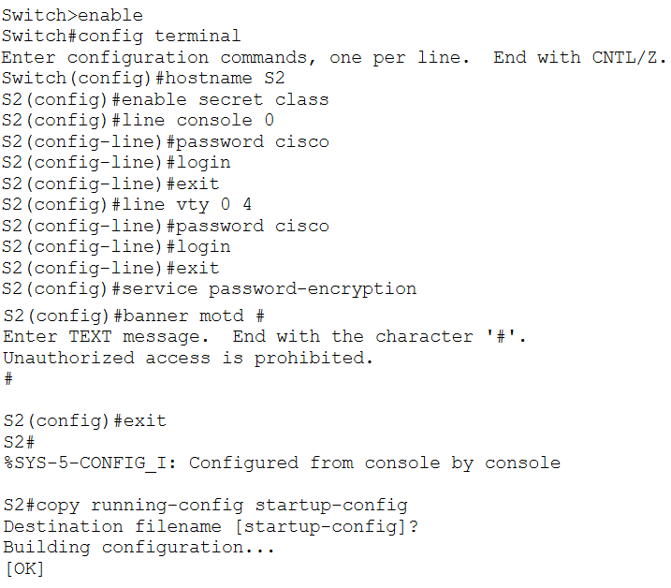

1. Each of the PCs were given host addresses based on the Addressing Table.

PC-A:

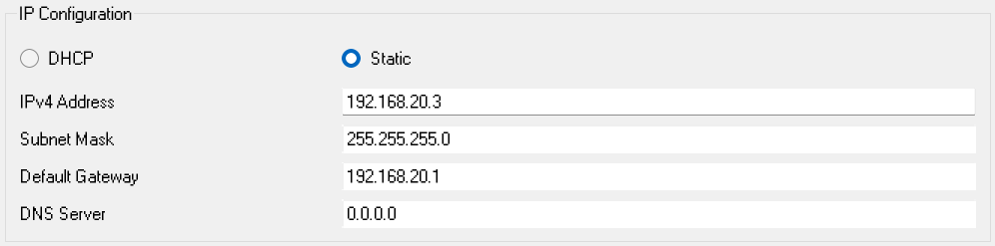

PC-B:

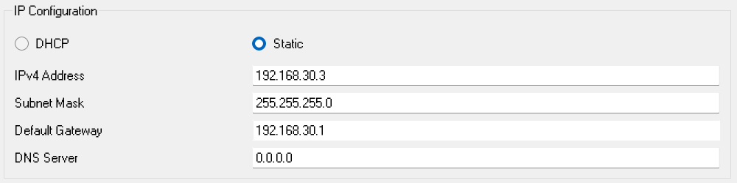

1. The VLANs on each switch were created and named according to the provided table.

S1:

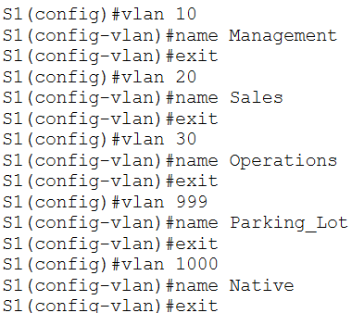

S2:

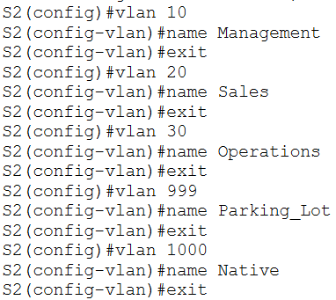

1. The Management interface and default gateway for each switch was configured based on the Addressing Table.

S1:

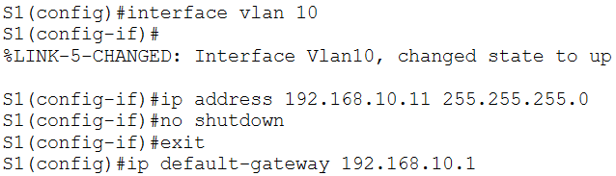

S2:

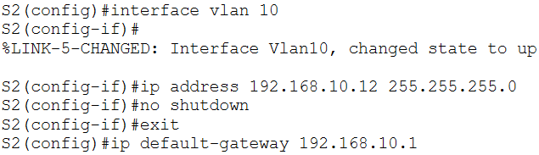

1. Unused ports on each switch were configured to use the Parking_Lot VLAN with static access mode. The ports were deactivated.

S1:

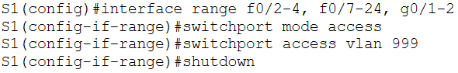

S2:

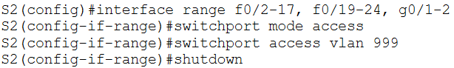

1. Used ports were assigned to the respective VLANs with static access mode on each switch.

S1:

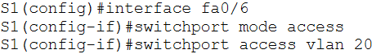

S2:

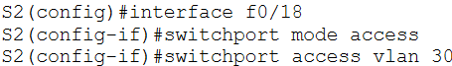

1. It was verified that the VLANs are assigned to the correct interfaces.

S1:

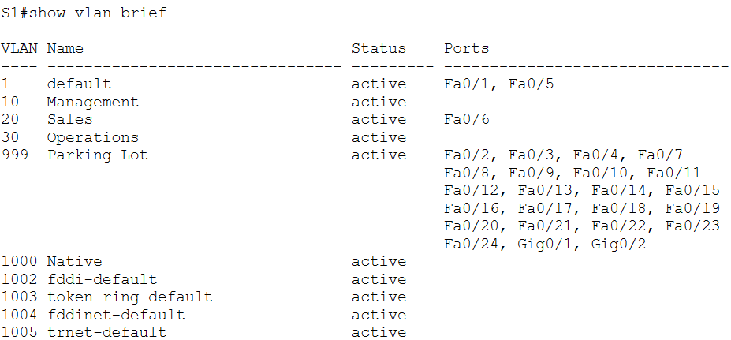

S2:

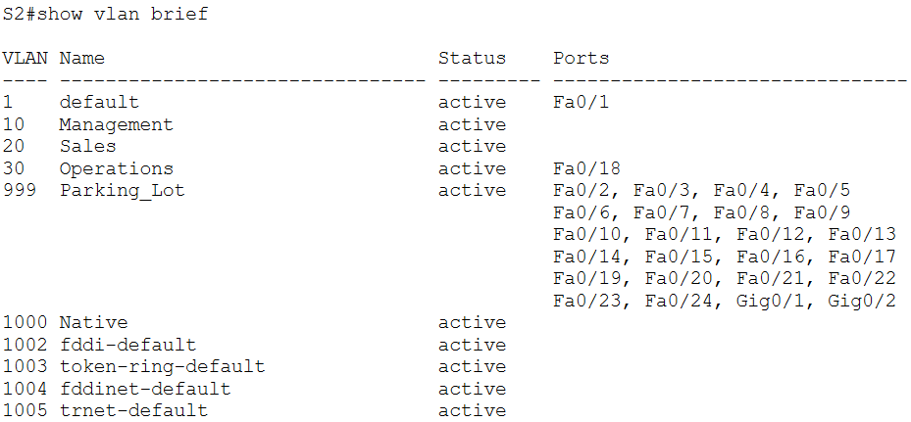

1. Static trunking on the fastEthernet0/1 interface was configured on both switches with native VLAN 1000.

S1:

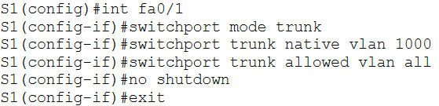

S2:

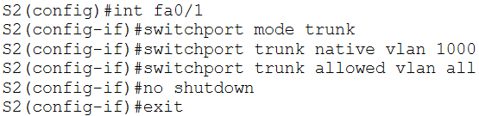

1. Trunking ports, native VLANs and allowed VLANs were verified.

S1:

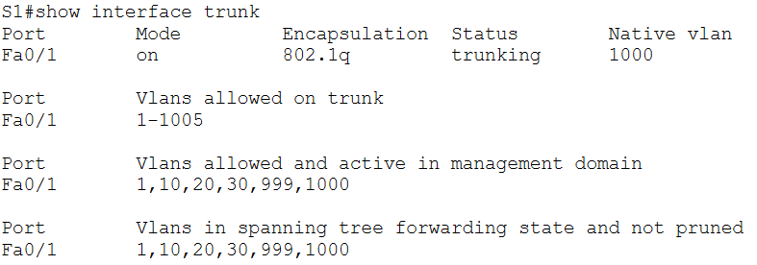

S2:

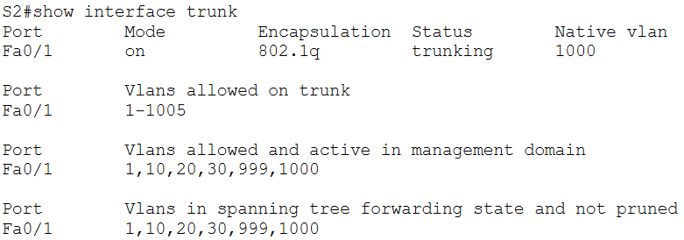

1. Switch S1’s trunk interface f0/5 was configured.

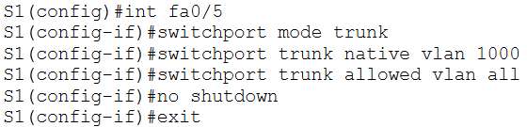

1. The running configuration was saved to the startup configuration file.

S1:

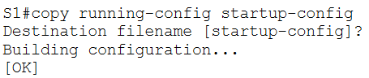

S2:

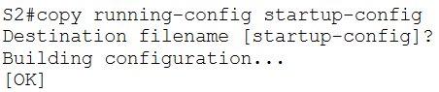

1. Trunking was verified.

S1:

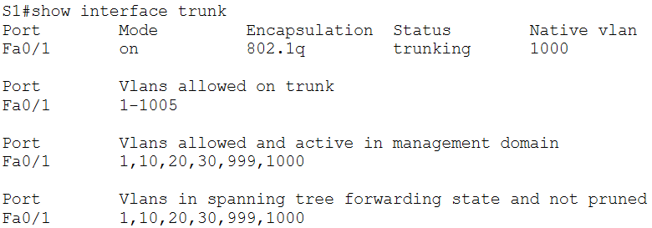

S2:

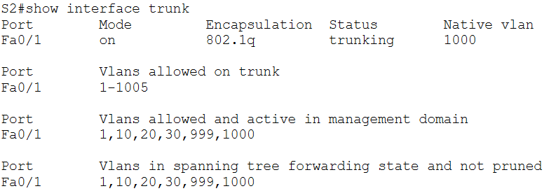

1. The port Fa0/5 does not appear on the list when verifying trunking for switch S1 if G0/1 is down on router R1. The interface was enabled to verify the trunking on switch S1.

R1:



S1:

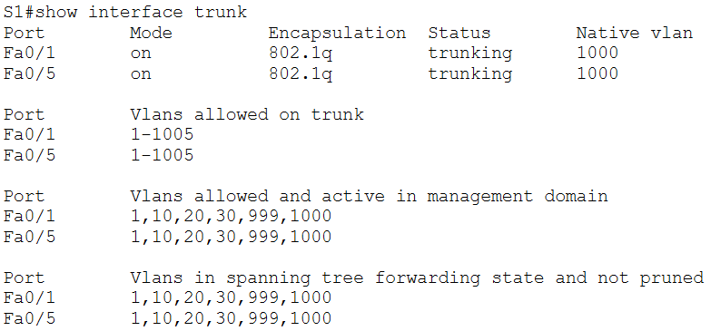

1. The sub-interfaces on interface g0/1 on router R1 were configured.

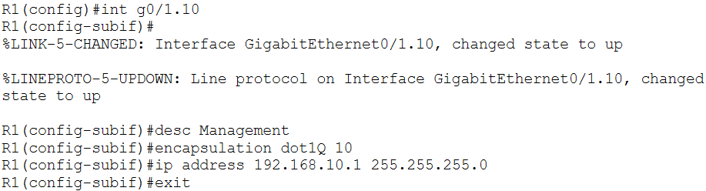

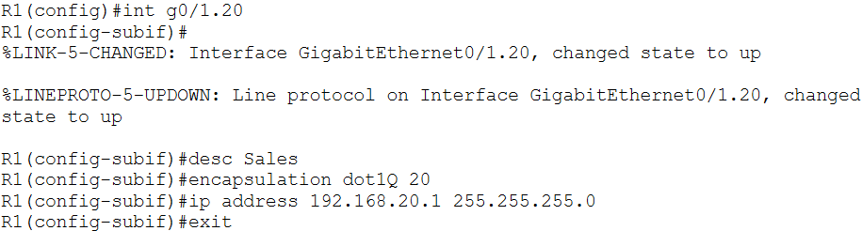

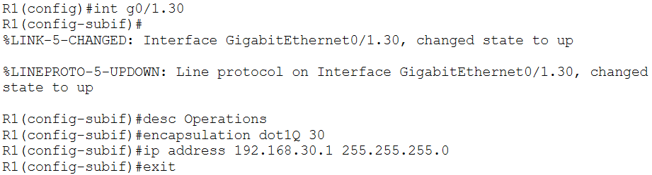

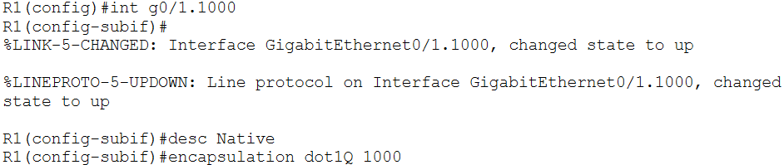

1. It was verified that the sub-interfaces were operational.

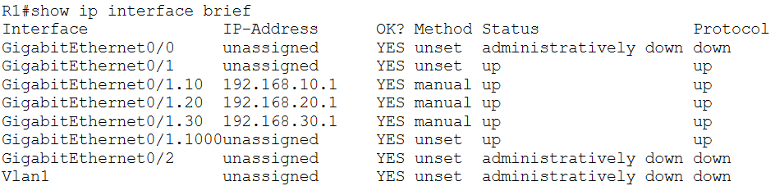

1. Tests were conducted from PC-A.

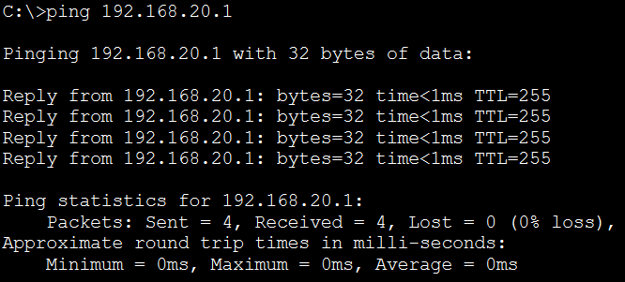

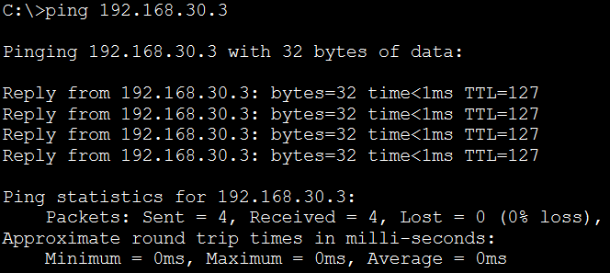

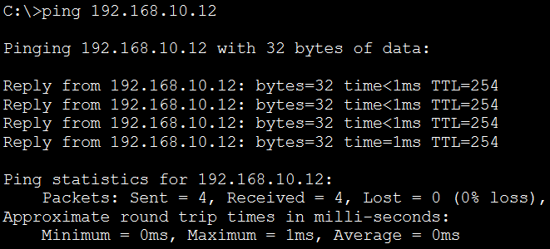

1. Tests were conducted from PC-B.

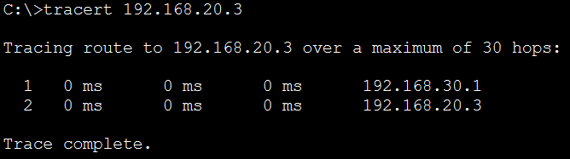

The intermediate IP address shown is 192.168.30.1.

TASK #02:

1. The GigabitEthernet0/2 port on the MLS was configured as a router port with the IP address from the Addressing Table.

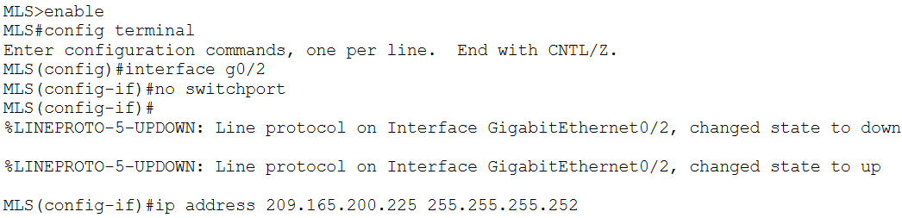

1. Connectivity to the Cloud was verified.

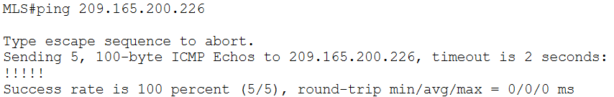

1. VLANs were added to the MLS according to the provided table.

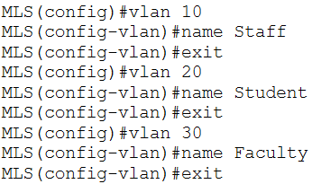

1. The SVI interfaces for the VLANs were configured and activated.

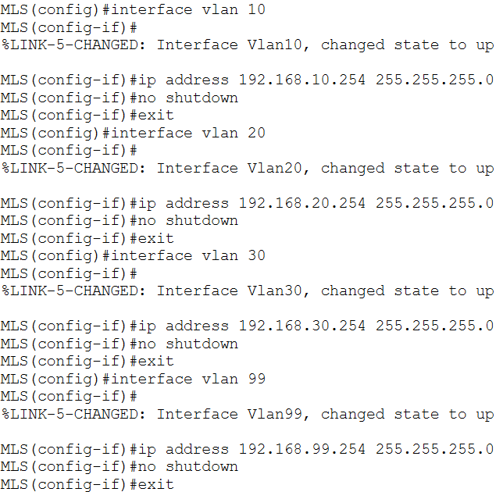

1. The interface g0/1 on the MLS was configured for trunking.

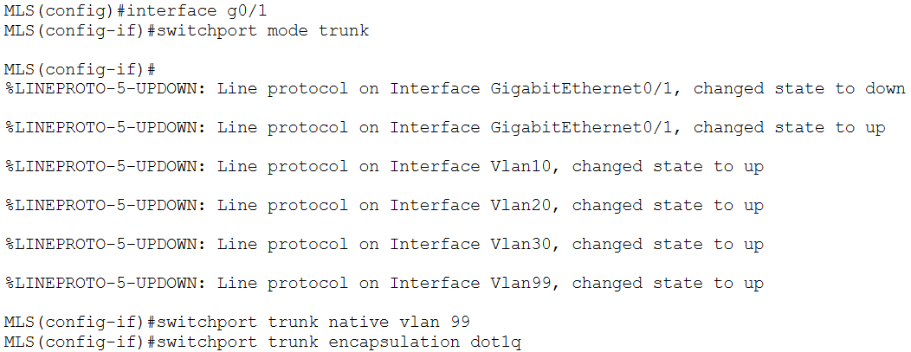

1. The interface g0/1 of S1 was configured as a static trunk and the native VLAN on the trunk was configured.

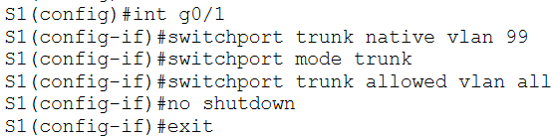

1. It was checked if there were any active routes on the MLS. There were not.

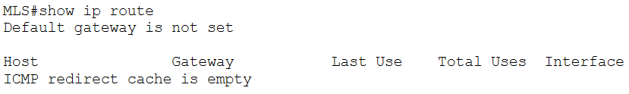

1. Routing was enabled on the MLS.

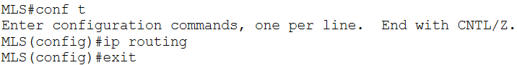

1. It was verified that routing was enabled.

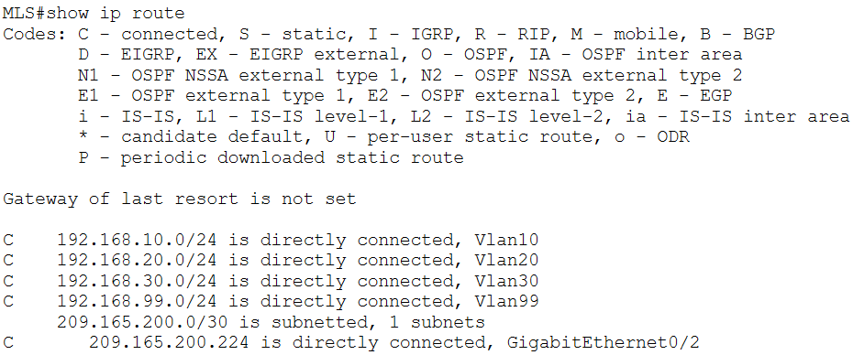

1. End-to-end connectivity was verified.

From PC0 to PC3, to verify the connectivity within VLAN 10:

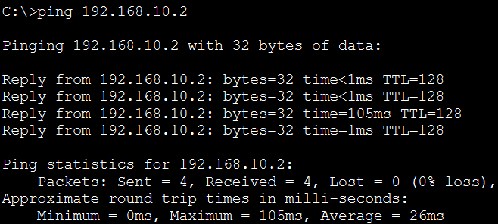

From PC1 to PC4, to verify the connectivity within VLAN 20:

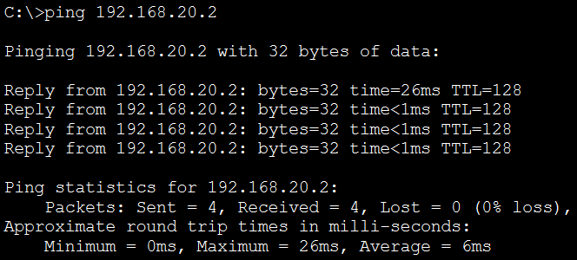

From PC2 to PC5, to verify the connectivity within VLAN 30:

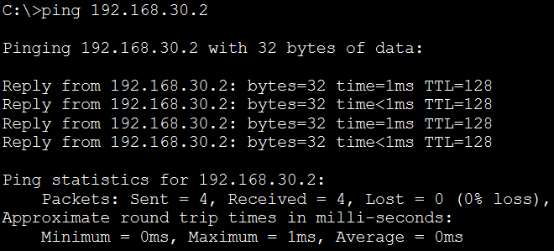

From S1 to S2, to verify the connectivity within VLAN 99:

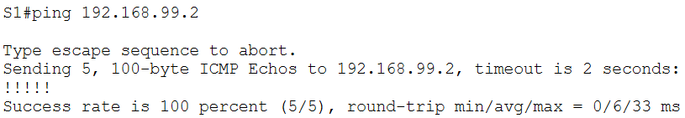

From PC0 to PC1, to verify inter-VLAN routing:

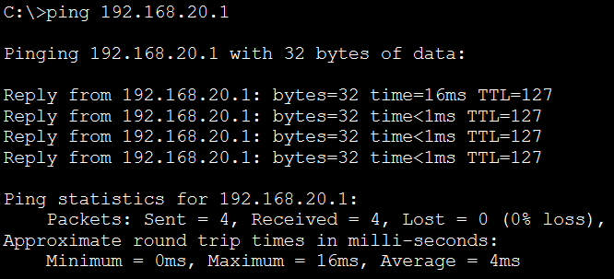

From PC0 to the specified address inside Cloud:

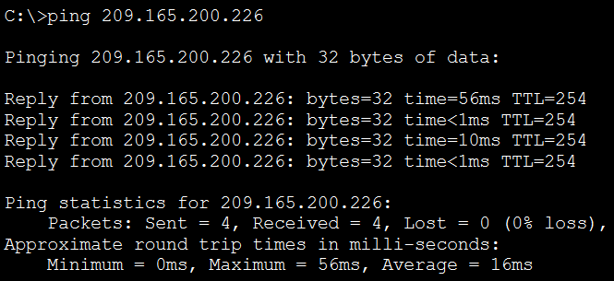

**Observation**:

Task 1:

S1:

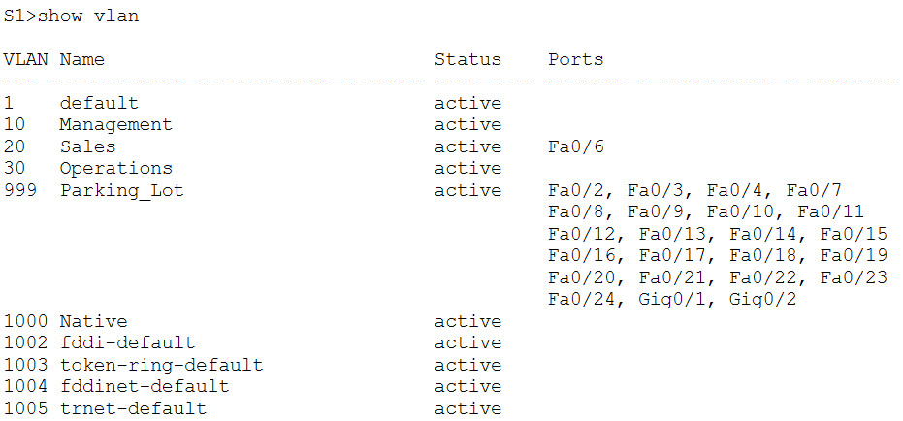

S2:

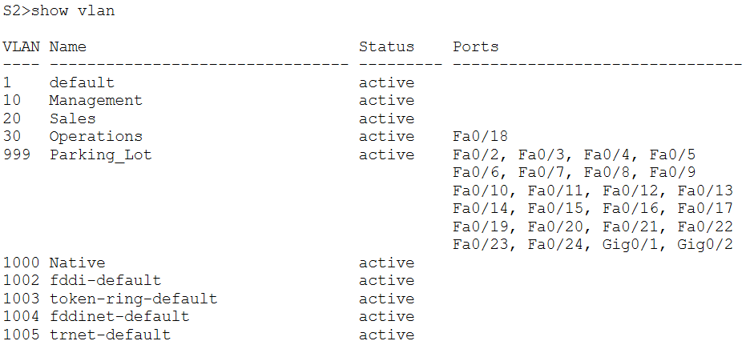

Task 2:

S1:

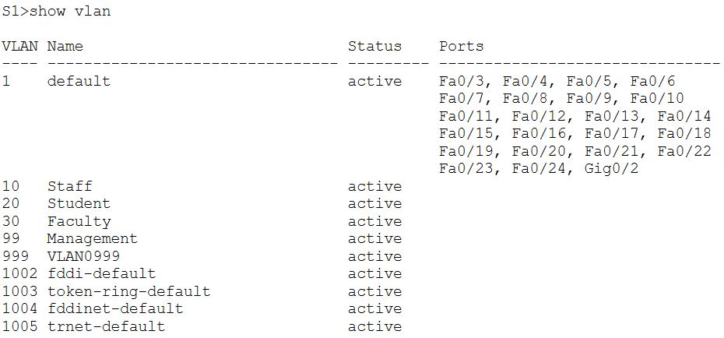

**Challenges**:

The length of the first task made it somewhat difficult to keep track of what was going on. I found it confusing at time having to go back and forth between different interfaces and became anxious about whether I was making mistakes.